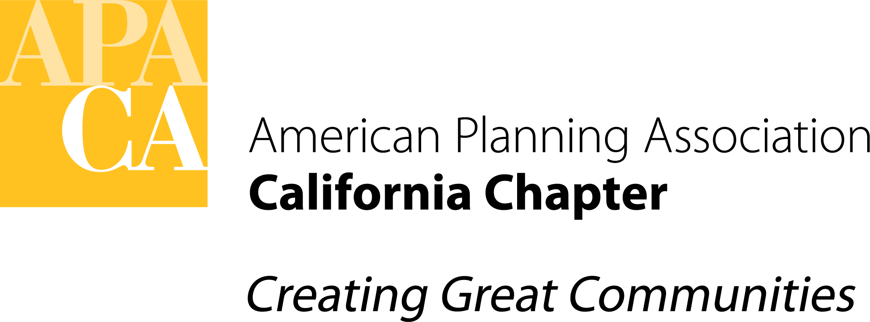

DATE: December 9, 2021

TO: APA California Chapter Board

FROM: Ashley Atkinson, President

SUBJECT: Establishment of an Annual Sponsorship Program

The Board is asked to consent to the establishment of an annual Chapter sponsorship program, complementary to and in addition to existing conference sponsorship and section sponsorship opportunities, beginning in 2022.

Background

Establishment of an annual sponsorship program constitutes the final pending item in the President’s 2021 work program. Conceptual discussion of such a program has been underway since 2020, and in fall 2021 research was undertaken to further develop it with the support of intern Shiromi Welipitiya. This research included a review of the sponsorship programs offered by the sections, other chapters, and peer organizations, as well a survey of the sponsors of the conference, sections, other chapters and the California Planning Foundation. The results, along with the Chapter’s proposed program tiers, benefits, and rates, are available in this spreadsheet.

The approach to the program was developed in consultation with the Section Directors, Executive Board, Conference Manager Deene Alongi, and representatives of the California Planning Foundation. It was conceptually approved by the Executive Board on November 19. Key points are that:

- The Chapter currently offers no sponsorship opportunity outside the conference
- Calling Card & display ads in CalPlanner are defunct and did not produce any revenue in 2020, down from $6,000 in 2017
- Sections offer individual sponsorship programs; 31 2021 Section sponsors have not sponsored the conference or purchased a Calling Card ad in recent years
- Only 25% of 2019-2021 Conference sponsors also sponsored a Section in 2021
- Updated annual offerings, and a coordinated approach, could result in better engagement with more sponsors, increased revenue, and improved outcomes for all
- Discounts on the Chapter’s annual sponsorships will be offered to firms that sponsor either the Conference or multiple sections
- Ten firms have demonstrated strong support for APA by sponsoring 3-6 opportunities in recent years; these firms will be proactively offered a comprehensive or custom package that would be coordinated by staff

If approved by the Board, the specifics of the program would be finalized, collateral materials developed, and the program advertised beginning in January or February 2022. Administration of the program is expected to be conducted by the approved association management firm in coordination with Sections and the Conference Manager.

