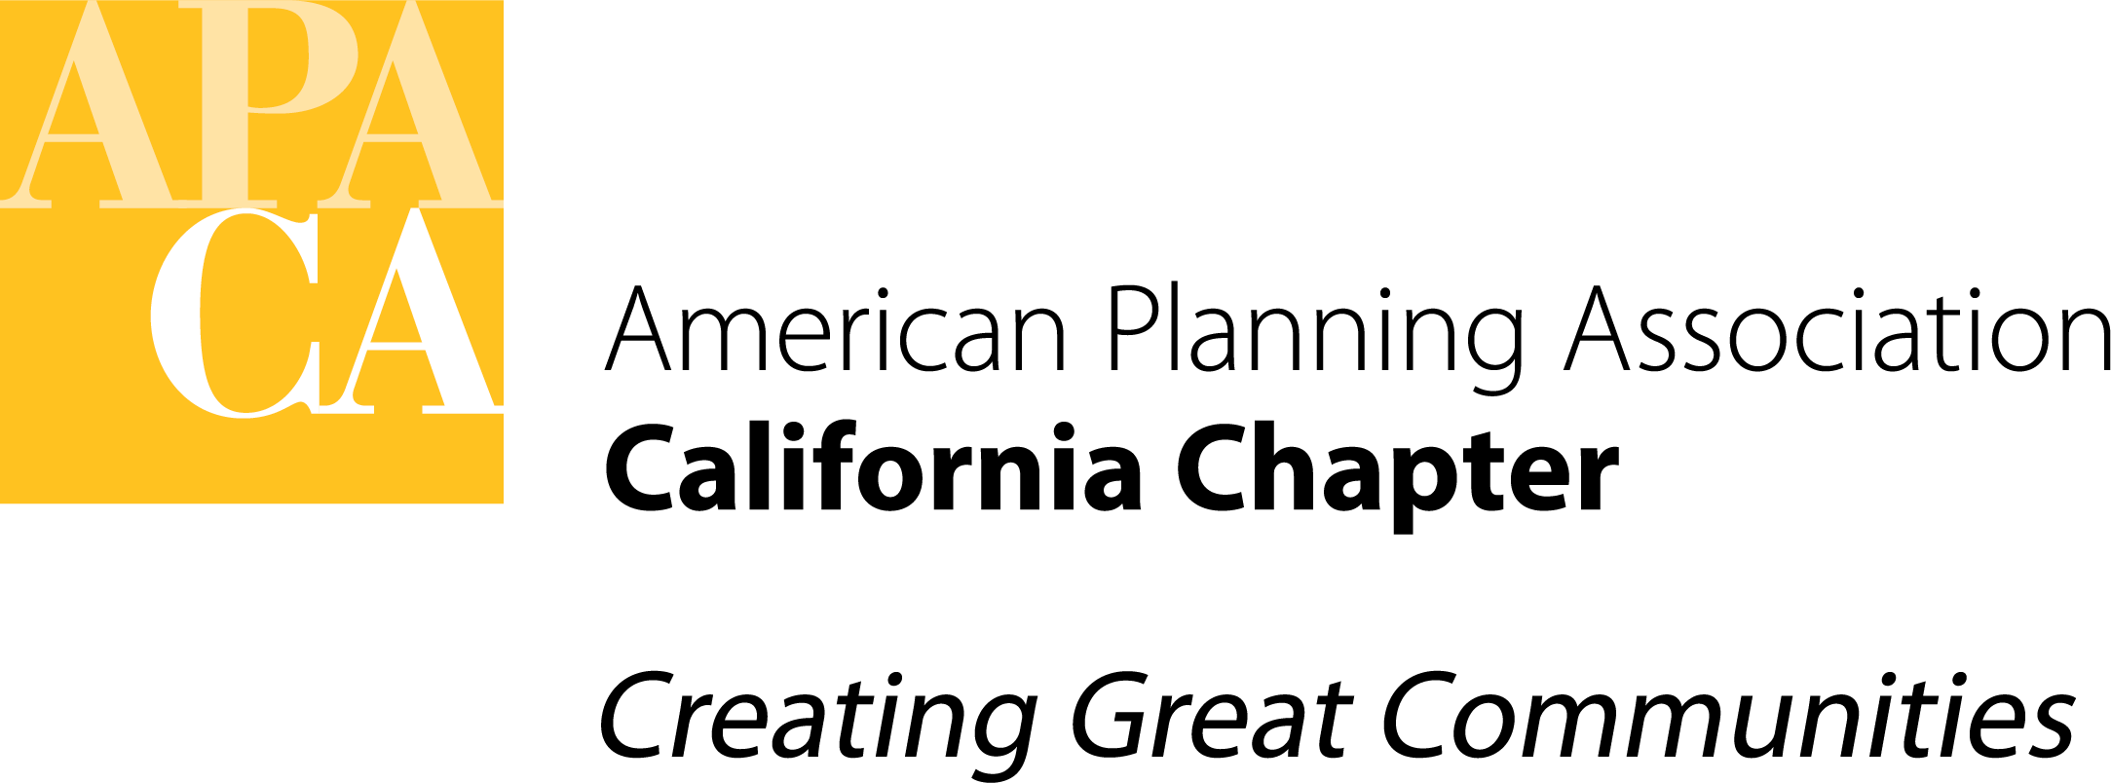

DATE: December 7, 2021

TO: APA California Chapter Board

FROM: Julia Lave Johnston, Past President

SUBJECT: California Chapter 2022 Board Elections

My Elections Report to the Executive Board on October 2, 2021, resulted in a further discussion at the October 15 Executive Board meeting about how to make the elections process more equitable and increase membership participation in running and voting. In that conversation, the board asked me to further investigate the options for opting out of National’s Consolidated Elections.

I spoke to Mike Welch, who is in charge of the Election Process. National is actually considering ending the Consolidated Election Process which is odd since most of the chapters use it (according to Mike and to the chapter board members I spoke with). National just sent out a survey to all chapters to determine how they felt about the Consolidated Election Process but with little opportunity for constructive input on how to improve the process. Hopefully if National continues to provide a consolidated process, we could suggest improvements.

I spoke to several other large chapters (Texas, Florida and New York Metro) and they use National’s process without any alterations and with no additional candidate interviews or voter information.

Recommendation for Consolidated Elections

Background from October 15

- The Board should reconsider whether using the National election cycle and ballot for Chapter elections is still working for the Chapter.
- Joining the National ballot process initially was designed to increase the number of California members voting, and to remove the responsibility to conduct the election from the Chapter. However, it has not increased the percentage of members voting and it still requires Chapter staff and Board member time to compile all the information to send to National.
- The main problem, however, is that the timing of the National election does not match the Chapter’s. The slate must be determined by March which makes securing candidates difficult and the election is held in May -- seven months before the Chapter’s new elected members take office.
- If the Chapter ran its own elections, the election could be held later in the year closer to the new terms starting in January, give more time to vet and recruit candidates, require a video interview available to members similar to what National is now doing (rather than continuing to use 500 words and a picture), allow a meet-the-candidates session at the conference and/or voting during the conference to increase member voting and participation, and ensure a more transparent and diverse process. This will require additional Board and staff time, but not substantially more than what is required now and with more time to complete all of the tasks.

The goals of these changes are to (1) ensure the competency of candidates while increasing equity and inclusion and (2) to more fully engage our members in the election process.

My recommendation is to form a committee/working group to explore the options for the Chapter to hold its own elections including cost information and security considerations. The sections currently run their own elections and might have insight into best practices. As part of this process, the working group should consider how to integrate equity into our elections and support the development of future APA California leaders.

Recommended Election Policy & Procedures Updates
In my report, I also made the following recommendations to update the Election Policy & Procedures. If the board decides to stay with the current National Consolidated Elections as they consider further changes, I would encourage the following changes to the Policies & Procedures from my original report.

Biographical Background and Position Statements
In order to make the process more transparent and equitable, this year the Nominating Committee held optional interviews with the committee and the candidates. As we try to recruit more diverse board members, some of these candidates may not have as much APA experience. In order to give them a fair chance, the committee felt that interviews were appropriate. National APA’s Chapter Presidents Council went a step farther and created videos of candidates answering questions to show all voters.

I recommend that we update the below section to require an interview as part of the process. I would also recommend that we do require a resume but do not require a photo or two copies of the candidate statement until later after the candidates have been slated. In addition, we should allow candidates to update their statements after they have been slated. We might want to consider providing a rough format for the statement so they look consistent.

Current Language:
1.2.4 - Biographical Background and Position Statements.
All potential candidates desiring to be considered for nomination shall submit a Biographical Background and Position Statement (prepared in accordance with the guidelines in Appendix 1) to the Nominating Committee.
• Candidates may not change their position statement once it has been submitted. Position statements shall be submitted electronically via e-mail.
• Individual Background and Position Statements shall not exceed 600-words.

Recommended language:
1.2.4 - Biographical Background and Position Statements.
All potential candidates desiring to be considered for nomination shall submit a Biographical Background and Position Statement (prepared in accordance with the guidelines in Appendix 1, 1.0 and 2.0. 3.0, the submission of two electronic copies and a photo are not required until after a candidate has been slated.) Candidates shall also submit a resume to the Nominating Committee and participate in a short online interview with the committee.
• Candidates may update their position statement once it has been submitted. Position statements shall be submitted electronically via e-mail.
• Individual Background and Position Statements shall not exceed 600-words.

